Aprimo DAM Configuration Mover

-Notes and instructions –

Tools consists of two sections: Export and Import.

Filter the objects you’re exporting

Environment details to establish connection

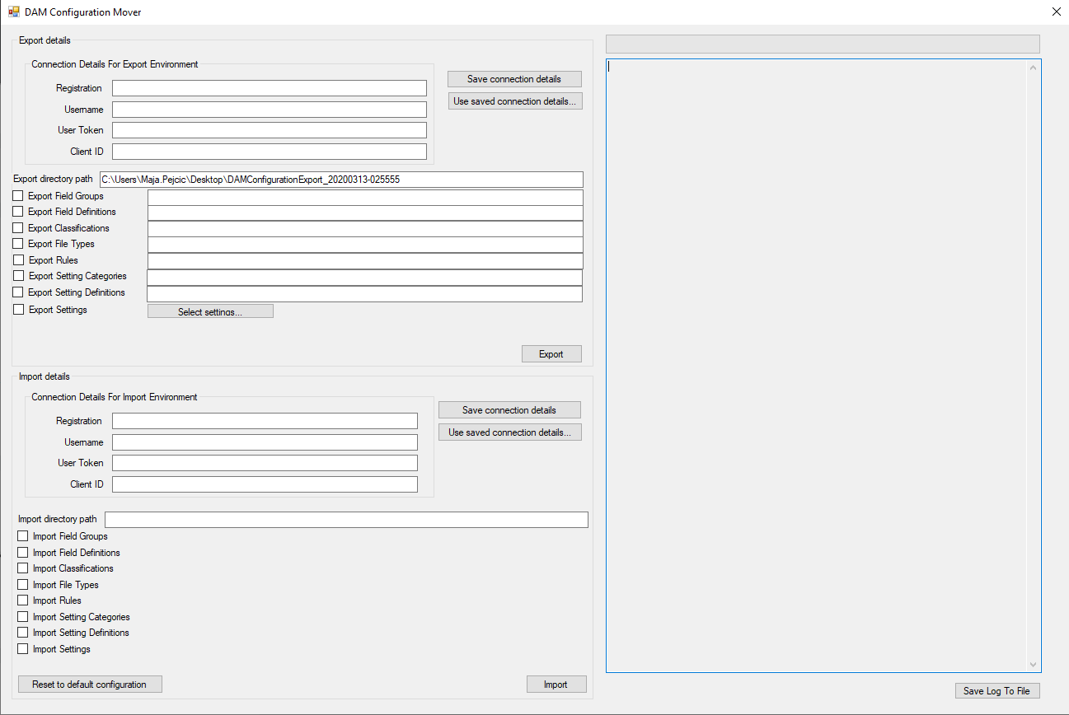

Progress bar and logs

Select which objects to export or import

Save connection details locally and use pre-saved connection details

Reset the configuration on destination environment. To be used with extreme caution!

Generally, you would run the export from already set up environment (usually Sandbox). Export option produces XML files that keep all necessary information about exported objects in DAM. When exporting, you can choose which objects need to be exported, and you can filter them as needed. Any search expression that works in DAM for particular object will also work in filter field next to object export checkbox. All export XMLs are saved within a folder, which you will need to note down for import.

Once you run the export, you can manipulate exported documents as you need before you run the import using those files (example: you export all field definitions from Sandbox, but only need to import a couple. You would remove nodes from XML that are unnecessary before running the import). Import option in tool requires you to provide a path to folder where exported XMLs live. The importer will then use XML files from that folder for import. Note: if your import folder contains files for objects that you have not selected for import, those would be ignored.

For running the tool, you will need following input information for source and/or destination:

* Registration/domain of environment
* Username for the user who is running the import. For the import to be successful, that needs to be user with system administration privileges.
* User Token – generate user token if not generated already, instructions are given here:

<https://developers.aprimo.com/marketing-operations/rest-api/authorization/>

* Client ID – generate client if not generated already, instructions are given here: <https://developers.aprimo.com/marketing-operations/rest-api/authorization/>
* Path to folder containing exported XMLs for running imports

Tool will show you progress via progress bar and logs. Logs can be saved in a text file using “Save Log To File”.

To help you with providing environment details, the tool offers option to save (locally) all provide environment details and use them at a later time. For this purpose, tool will create “Connection Details.xml” in the deploy directory as you start saving your environment details, so do not remove this file if you want to be able to reuse authentication details in the future.

There is a button to reset destination environment to default configuration in the bottom left corner. If you choose this option, all field groups, field definitions and classifications will be removed from destination environment, so please use this option with extreme caution. Once the button is clicked it will ask you to confirm the cleanup via warning message.

DAM configuration items covered by Configuration mover

# Field groups

Mover copies field group only, using field group name as identifier. If field group exists at destination (with same name) mover will skip it.

Field group members are imported through field import, ***however sorting the members as in source environment is not supported,*** for field groups that are controlling views/panels you would need to manually resort field definitions in field groups once you have copied over all field groups/field definitions.

# Field definitions

Mover copies almost all config for any type of field definitions, with following exceptions:

* not all labels in all OOTB available languages are exported - they are not provided in JSON for field definitions, only label in English is provided - NEED TO TEST IT IN AN ENVIRONMENT WITH ENABLED LANGUAGES
* enabled languages moving built into the tool, but NOT TESTED
* for record link fields, doesn't support 'Allow searching on nested properties and fields' since JSON doesn't support items.
* for classifications list fields, it's not possible to change parameter "Link records to the selected classifications" so the tool will not attempt it if you’re running the tool to update field definition.
* tested field types: Classification List, Text, Multiline text, Numeric, Date, DateTime, Option List, Text List, User List, HTML and Hyperlink
* NOT TESTED field types: Duration, Language List, User Group list, Record List, Record Link, Time – these are all implemented to cover import/export of all custom field parameters, but I haven’t had a chance to test.
* for OOTB fields (like smart tags), updating is not supported, you will see an error log for these.
* Watch for errors and warning within logs, warning messages might pop up to let you know certain piece of configuration wasn’t moved because of dependency missing (examples: if you’re moving classification list field but there’s no appropriate root classification on destination environment, the root classification would be set by default to top level, and you’ll get a warning from tool. Also, if you’re trying to copy a label in a language that doesn’t exist on destination, the move of field definition will proceed but will warn you that a label in an inexistent language was not set.) These kinds of warnings/missing of dependencies are considered non-critical for copying the configuration over, therefore the tool will create an object on destination. If you provide that dependency and run the tool again, the definition will be updated as expected. However, the tool won’t create a field definition without a critical piece of configuration that would then require you to delete the definition and recreate it (example: classification list field won’t be created without properly checking the box “Link records to the selected classifications” if it was checked on source environment).

# Classifications

Tool copies all classification configuration except for images – adding image via REST API to classification is not supported. In order for fields/field groups to be registered and appropriate values to be filled in on classifications, those objects need to exist on destination, otherwise tool will report warning and skip this part of configuration for classification.

# File Types

Tool copies all file types configuration including registered field group, fields and tag. The order of Cataloging action and Media Engines is being copied from source environment.

# Setting Categories

Mover copies setting categories only, using category name as identifier. If setting category exists at destination (with same name) mover will skip it. Intended for custom setting categories.

# Setting Definitions

The tools is able to export and import all types of setting definitions with their default values.

Notes:

* Setting Category needs to exist in destination to import setting definition of that category.
* Tool cannot copy over “Allow anonymous access” flag, as it is not supported by REST API.

# Setting Values

In order to export settings, you will need to click on selection button next to settings export checkbox, select the settings you’re interested in exported, as well as user groups if setting is changed on user group level.

Notes:

* Role settings are not supported by this tool. They can be exported/imported as security permission using Security Exporter and Security Importer tools.
* All settings you select for export will be exported from system level, then selected user groups will be checked to see if any of those settings have values on user group level. Is user group level value doesn’t exist, then only system level setting will be exported.

Tool only exports/imports from these two levels – system level and user group level. User level settings are not supported by REST API atm.

# Rules

Tool can export and import Rule configuration. However, this feature has not been fully tested, in particular with regards to condition “Currently logged on user”, as well as modifying existing rules, so use with caution. Editing existing rules via the tool is not supported, so can be used only for initial creation of rules. Worst case scenario – your rule won’t be moved 😊

# General recommendations for usage

This tool caches DAM objects in order to work out dependencies between them. It is best if all DAM objects are imported one by one, restarting the tool in-between imports.

***Import items in following order to avoid having difficulties with dependencies***:

* Field groups
* Classifications – the tool will not fail if field definitions are missing, it will just ignore missing fields to register and issue a warning; we will need classifications created first for Classification List field definitions to be added
* Field definitions – tool will kick off rebuilding of search indexes once all field definitions are created. However, you will have to monitor when building of indexes is done in order to proceed with importing other items. After rebuilding of indexes is done, restart the tool so that caches can be rebuilt for dependencies.
* Classifications reingestion to register field definitions and fill all field values on classifications. Note that you don’t have to re-ingest all classifications but only the ones that:
  + Have fields registered on them
  + Have field values
  + Have slave classifications – with first import we’ve ensured all classifications are imported, so that now mapping can be established.
* File Types – after field groups and fields have been imported, index has been rebuilt and tool restarted, assuming there are any fields in File scope. Otherwise, there is no dependency for importing upon field definitions.
* Custom Setting Categories need to be imported prior to importing custom Setting Definitions that belong to those categories.
* Custom Setting Definitions need to be imported before importing Setting values.
* Settings values to be imported only if setting definitions are copied. Please know that for certain settings (.registeredFacets, .assetStudioRegisteredSpaces) setting values that are copied refer to environment specific object identifiers (field definition GUIDs or classification GUIDs). So after the import is finished please go to the setup of spaces for Asset Studio under Quick Start Guides and/or setup for facets and correct the identifiers (provide adequate field definitions and/or classifications for facets and spaces).
* This tool uses extensive caching of DAM objects (field groups, field definitions, classifications etc.) to optimize running time. With that in mind it is recommended to run imports of individual objects separately especially for dependent objects – meaning select for example only classifications to be imported, once that’s finished restart the tool and run field definitions import etc.